1. 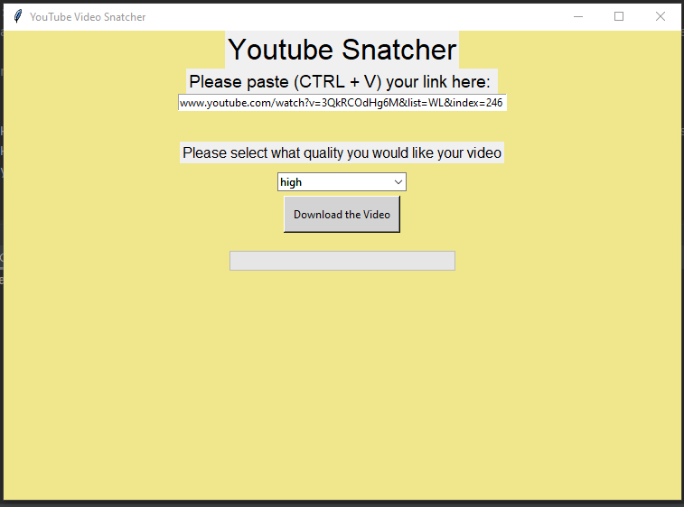
2. 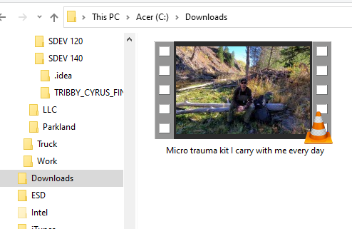

I was having issues with allowing the user to decide on where to save the file, no matter how I changed the coding, nothing worked. I ended up taking out the savefile dialog box and writing in a set code of where it will be saved. It has to be changed by the user for where they want to save the video file manually.